Module 1 - Design principles & Patterns:
Exercise 2: Implementing the Factory Method Pattern:
Create a project named FactoryMethodPatternExample with the following structure:
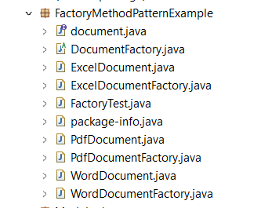

1.Document Interface
document.java:
package FactoryMethodPatternExample;

public interface document {
void open();

}

2. Concrete Document Classes:
WordDocument.java:
package FactoryMethodPatternExample;

public class WordDocument implements document{
public void open() {
System.out.println("Openeing Word Document");
}

}

PdfDocument.java:
package FactoryMethodPatternExample;

public class PdfDocument implements document{
public void open() {
System.out.println("Openeing PDF Document");
}

}
ExcelDocument.java:
package FactoryMethodPatternExample;

public class ExcelDocument implements document{
public void open() {
System.out.println("Openeing Excel Document");
}
}

3.Abstract Factory
DocumentFactory.java:
package FactoryMethodPatternExample;

public abstract class DocumentFactory {
public abstract document createDocument();

}

4.Concrete Factories
WordDocumentFactory.java:
package FactoryMethodPatternExample;

public class WordDocumentFactory extends DocumentFactory{
public document createDocument() {
return new WordDocument();
}

}

PdfDocumentFactory.java:
package FactoryMethodPatternExample;

public class PdfDocumentFactory extends DocumentFactory{
public document createDocument() {
return new PdfDocument();
}

}

ExcelDocumentFactory.java:
package FactoryMethodPatternExample;

public class ExcelDocumentFactory extends DocumentFactory{
public document createDocument() {
return new ExcelDocument();
}

}

5. Test Class
FactoryTest.java:
package FactoryMethodPatternExample;
public class FactoryTest {
public static void main(String[] args) {

DocumentFactory wordFactory = new WordDocumentFactory();
document wordDoc = wordFactory.createDocument();
wordDoc.open();

DocumentFactory pdfFactory = new PdfDocumentFactory();
document pdfDoc = pdfFactory.createDocument();
pdfDoc.open();

DocumentFactory excelFactory = new ExcelDocumentFactory();
document excelDoc = excelFactory.createDocument();
excelDoc.open();
}
}

Output:
